Algebra 3-4 Name: _______________________
Worksheet 1.5 Block: ______

Decide whether the given number is a solution of the inequality.

1. 2x + 9 < 16 when x = 4 2. 10 – x 3 when x = 7

3. 7x – 12 < 8 when x = 3 4. 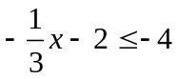 when x = 9

5. –3 < 2x 6 when x = 3 6. –8 < x – 11 < -6 when x = 5

Solve the inequality. Graph the solution.

7. 4x + 5 > 25 8. 7 – n 19

9. 5 – 2x 27 10. 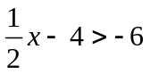

11. 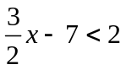 12. 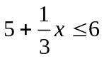

13. 4x – 1 > 14 – x 14. –n + 6 < 7n + 4

15. 4.7 – 2.1x > -7.9 16. 2(n – 4) 6

17. 2(4 – x) > 8 18. 5 – 5x > 4(3 – x)

19. -2 x – 7 11 20. –16 3x – 4 2

21. –5 -n – 6 0 22. x + 2 5 or x – 4 2

23. 3x + 2 < -10 or 2x – 4 > -4 24. –5x – 4 < -1.4 or –2x + 1 > 11

